**MINI PROJECT – I**

**(Session 2018-19)**

**Group No. 71**

**GLA Helpline App**

**SYNOPSIS**

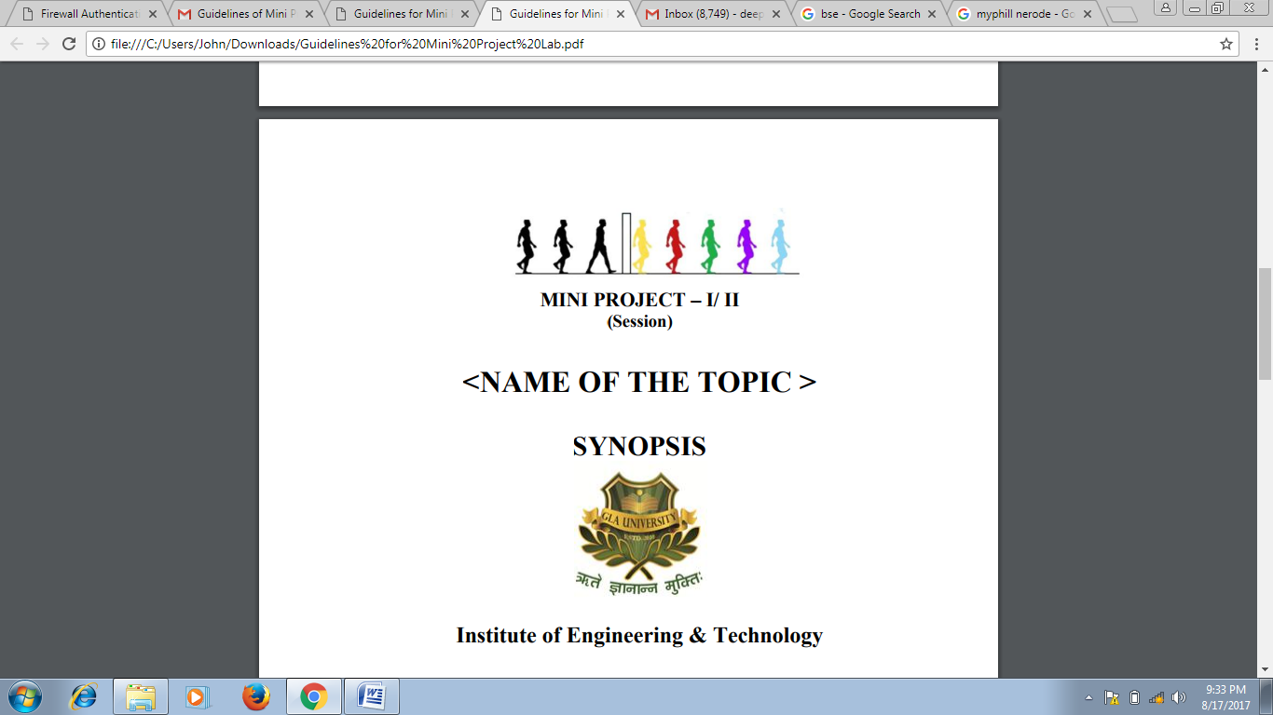

**Institute of Engineering & Technology**

**Team Members**

Gagan Saxena (161500210)

Rajeev Pachauri (161500433)

Prakhar Srivastava (161500392)

Siddhant Bansal (161500557)

**Supervised By**

Mr. Sandeep Kr. Rathore

Assistant Professor

Department of Computer Engineering & Applications

**Group Information:**

**Student 1:**

Gagan Saxena

C (19)

9458615139

[gagan.saxena_cs16@gla.ac.i](mailto:gagan.saxena_cs16@gla.ac.in)n

**Student 2:**

Prakhar Srivastava

E (18)

9648100199

[prakhar.srivastava_cs16@gla.ac.in](mailto:prakhar.srivastava_cs16@gla.ac.in)

**Student 3:**

Rajeev Pachauri

E (46)

8194040282

[rajeev.pachauri_cs16@gla.ac.in](mailto:rajeev.pachauri_cs16@gla.ac.in)

**Student 3:**

Siddhant Bansal

F (63)

8476022132

[siddhant.bansal_cs16@gla.ac.in](mailto:siddhant.bansal_cs16@gla.ac.in)

**Project Proposal:**

A software has to be developed for helpline to the members of institute who are seeking for help

(report any unusual activity like any mishappening or fighting activity, etc.) or improvement in management of the institute.

This application provide help to members of institute of some kind like, any misbehaving, mishappening etc. complaint can be filed or provided by the members to the higher authority and also inform to the security for special purpose (in case of security purpose or fighting).

This application also provides medical help (any member of the institute can file complaint for medical help if any person is in need of it, one can even call for ambulance in emergency conditions), complain of suspicious object or activity for the members of the institute.

**Benefits Of Application :**

* A complaint can consist a text, image, video or even an audio file.
* A complaint can be sent by any member of the institute, at any time.
* Ambulance in medical emergency can be called at any time, even complaint of cleanliness in hostel and campus can be filed at any time and effective results can be seen with improvement.

**Broad Requirements:**

Hardware Requirement :

* Laptop (i5 processor with minimum 8GB RAM)
* Smartphone with Android OS
* Internet facility
* OTG Cable

Software Requirements:-

* Android Studio 3.0.2
* Photoshop (For logo)
* Google Chrome
* Web server
* Vysor
* Other Tools

________________________________________________________________________